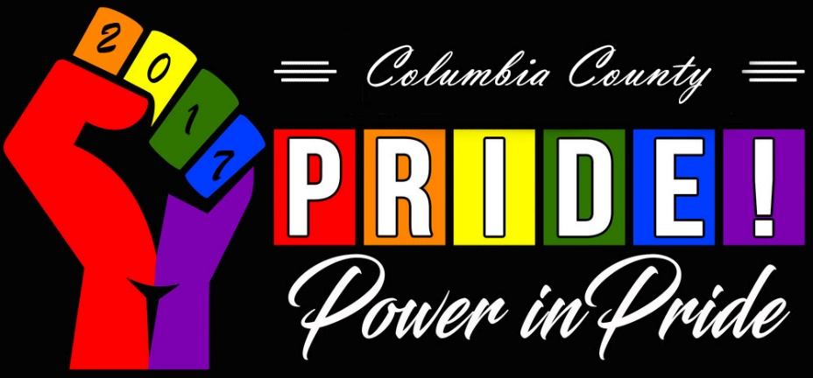

Columbia County Pride Parade 2017
Hold Harmless Agreement Motorized Vehicle Form

THIS FORM is required for each motor vehicle, motorized scooter, moped, or any other driven vehicle participating in the 2017 Columbia County Pride Parade. The owner and/or operator are required to complete this form, failure to provide the required information, or submitting false or misleading information, will immediately disqualify the vehicle, owner, and operator from participation in the 2017 Columbia County Pride Parade.

SPECIAL NOTE for motorized scooters, mopeds, and other applicable motor vehicles: Columbia County Pride Parade requires the operator of every motor vehicle to meet the State of Oregon requirements for insurance, registration, and licensing.

I, the undersigned, declare that I am participating in the 2017 Columbia County Pride Parade occurring on August 12th, 2017, in St. Helens, OR. that I am participating as the parade contingent with:

Name of Group, Organization, or Business

I will be driving: Year _ Make/Model License/Tag #

I further declare and certify:
I am fully licensed and insured to operate said vehicle/float.
I carry liability insurance to cover property damage and physical injuries to others, as required by the State of Oregon, and per the Special Note above, as applicable.
The vehicle is not modified in any way that may interfere with or prevent the safe operation of this vehicle. There are no modifications that may obstruct my view or prevent my safe operation of the named vehicle.

In consideration of the acceptance of this application, I agree to release and hold Columbia County Pride Parade, the 2017 Columbia County Pride Festival, their directors, officers, agents, representatives, employees and volunteers harmless and to promptly indemnify same from and against any and all claims, actions, damages, liability of every type and nature, including all costs and legal expenses incurred by the applicant or any other party, by reason of any activity arising under or in connection with my participation in the 2017 Columbia County Pride Parade, including loss of life, personal injury and/or damage to property arising from or out of any occurrence, omission or activity relating to such participation.

In the event Columbia County Pride Parade shall be made a party to any litigation commenced by or against the Participant, I shall hold Columbia County Pride and the 2017 Columbia County Pride Parade harmless and shall pay all costs, expenses and reasonable attorney's fees incurred or paid by them in connection with such litigation. Furthermore, I agree to pay all costs, expenses and reasonable attorney's fees that may be incurred or paid by Columbia County Pride Parade in the enforcement of any of the covenants, provisions and agreements hereunder.

Insurance Company

Policy Number Expiration Date

Signature

Printed Name Date

